

ITA1412 - ETHICAL HACKING EX - 8

Experiment 8: Nmap Service Version and OS Detection
Aim:
To execute and display the results of Nmap service version detection, aggressive scanning, and operating system detection commands in Kali Linux.
Software Requirements
- Operating System: Kali Linux
- Tool: Nmap (Network Mapper)
- Platform: Oracle VirtualBox
- Target IP Address: 127.0.0.1 (localhost)
Theory
Nmap (Network Mapper) is an open-source network scanning tool used for network discovery, security auditing, port scanning, service identification, and operating system detection. It helps users understand which hosts are active, which ports are accessible, and which services may be running on a target system.
Nmap provides different scanning options to collect information about a target. In this experiment, three options are used: service version detection (-sV), aggressive scanning (-A), and operating system detection (-O). The target address 127.0.0.1 refers to the local computer.
Procedure
Step 1: Open Kali Linux
Start the Kali Linux virtual machine in Oracle VirtualBox. Log in and open the terminal.
Step 2: Verify Nmap installation
Execute the following command:
nmap --version
This command displays the installed Nmap version and confirms that the tool is available. In this experiment, Nmap version 7.99 was displayed.
Step 3: Service Version Detection
Execute the following command:
nmap -sV 127.0.0.1
The -sV option attempts to identify the services and their version numbers on open ports. Nmap sends probes to accessible ports and analyzes the responses to determine which services are running.
Observation: The host was up, but all 1,000 scanned TCP ports were reported as closed. Therefore, no service versions were identified in the output.
Step 4: Aggressive Scan
Execute the following command:
nmap -A 127.0.0.1
The -A option enables several detection features, including operating system detection, service version detection, default script scanning, and traceroute where applicable. This option collects more information than a basic scan.
Observation: The host was up, and all 1,000 scanned TCP ports were closed. Nmap reported that too many fingerprints matched the host to provide specific OS details.
Step 5: Operating System Detection
Execute the following command:
nmap -O 127.0.0.1
The -O option attempts to identify the operating system by analyzing network responses and TCP/IP characteristics. This detection may require administrator privileges and may not always produce a definite result.
Observation: Nmap completed the scan, but it could not identify the specific operating system because the available fingerprint information was inconclusive.
Sample Output
The following is a summary of the output observed in the Kali Linux terminal:
Nmap scan report for localhost (127.0.0.1)
Host is up.

All 1000 scanned ports are in ignored states.
Not shown: 1000 closed tcp ports (reset)

OS and Service detection performed.
Nmap done: 1 IP address (1 host up) scanned.
Note: The exact output and scan duration may differ between commands.
Output: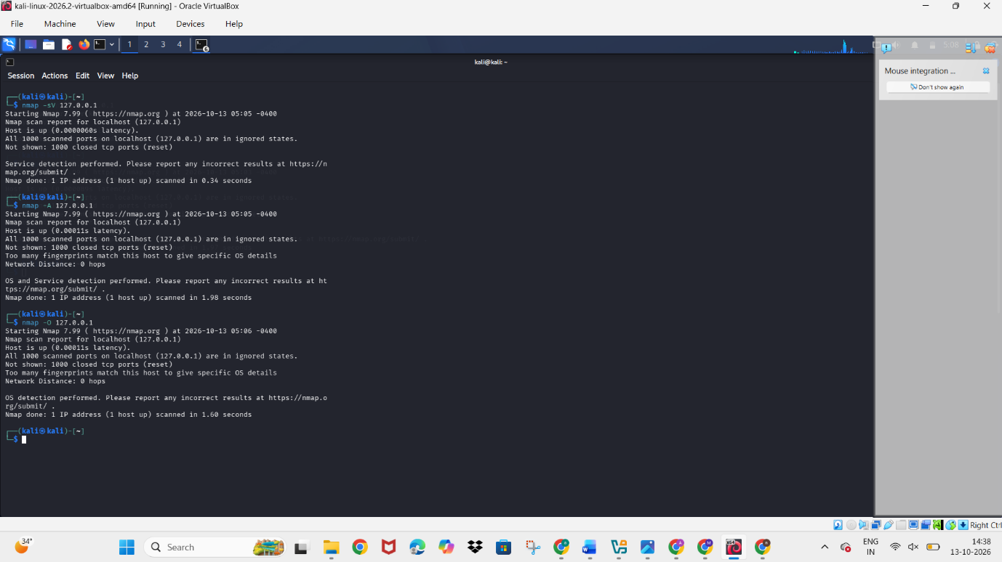
Result
Thus, Nmap service version detection, aggressive scanning, and operating system detection were successfully executed in Kali Linux against localhost (127.0.0.1). The scan confirmed that the host was active, but all 1,000 scanned TCP ports were closed. No service versions were identified, and operating system detection was inconclusive.

